User Manual
[E waste bin System]

Diploma in Infocomm & Security
Academic Year 2024 Semester 2

Role | AdmNo | Name
Leader | 233510P | Nixon Koh
Member | 232776E | Lin Yixiang Gareth
Member | 232093Z | Kirsty Chan Yeng Yan
Member | 232542N | Leonard Tan Jun Quan

Introduction

Purpose
This document is provided to a step-by-step guide on how to setup this project environment and operate the different system in our Application.

Hardware
Raspverry Pi
Sensors Used :- RFID
Buzzer
LED Green
LED Red
Water Sensor
Light sensor
Temperature sensor
Distance Sensor
UART

Software
Visual Studio 2015
- Windows IoT Core
- Windows Form Application

Environment Setup
Hardware
Component | Pin
Light Sensor | A0
Water Sensor | A1
Temperature Sensor | A2
Red Led | D2
Green LED | D3
Buzzer | D4
Ultrasonic Sensor | D5
RFID | RPI Serial Port

Admin
Username: admin
Password: admin123

Action Required
- App.Config : Connection string filepath needs to be changed to point towards database

User
Username: test13
Password: test13

Action Required
- App.Config : Connection string filepath needs to be changed to point towards database
- LanguageManager.cs:42 File path needs to be changed to local directory path for Translation.json in resources folder
- Form6:292 File path needs to be changed to local directory path for EwasteGuide.pdf in resources folder
- Set email of admin account in database to your own email.

Database Design
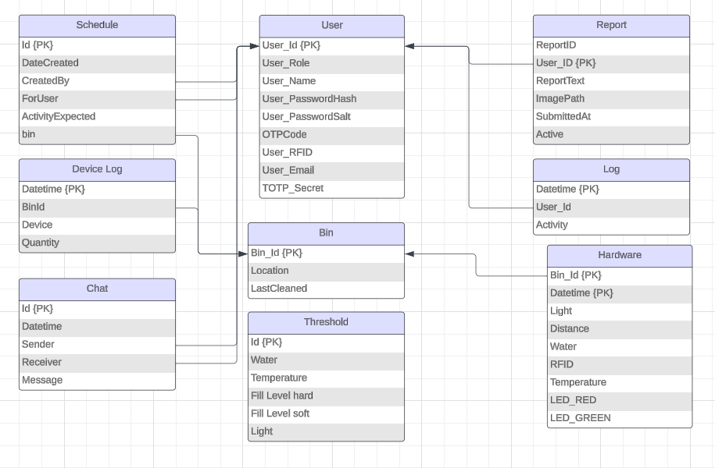

E waste Bin System Application | Admin

Description:
This application is a Smart E-Waste Management System designed to optimize waste collection through IoT technology, real-time data monitoring, and user-friendly dashboards. It aims to improve efficiency, accountability, and environmental impact in e-waste disposal.

Login Form/Logout

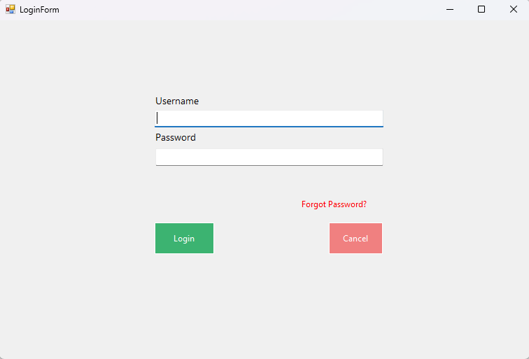

Purpose:
The feature is used for administrator to login into the dashboard to access the content and also logging out.

How it works:
- Fill in the username and password fields, and then click login. Once successful, message appears and administrator is logged in.
- If details are invalid, error message appears.
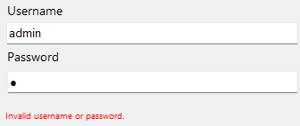

- When details are correct, login will be successful and administrator will be brought to dashboard.
- If administrator wants to log out, click on the log out button on the top right of the navbar.

Forgot Password

Purpose:
This feature is to allow administrators who forgot their password to reset conveniently. In order to reset password, administrator must first have enabled TOTP verification.

How it works:
- Administrator clicks on Forgot Password button in login form.
- Then a prompt for email will pop up.
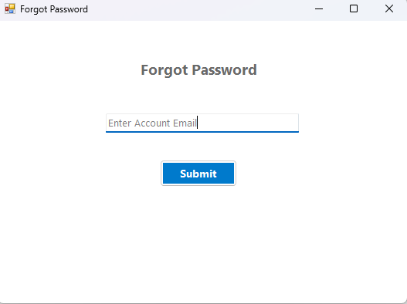
- If email does not exist or the account linked with the email does not have TOTP enabled, error message appears.
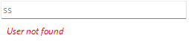
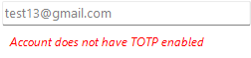
- Once system confirms email is valid, it brings them to TOTP verification
- After account is verified, administrator is brought to reset password form.
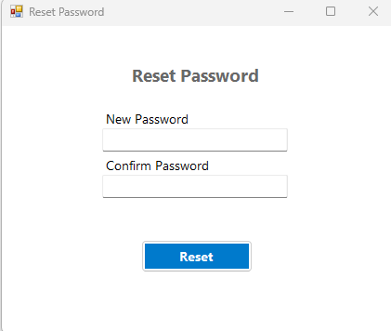

3.3 Password Hashing & Salting

Purpose:
This feature is to securely store passwords by transforming them into an unreadable format.

How it works:
- When administrator creates user or reset passwords, the password string will be hashed and salted into an unreadable format and stored in the ‘User’ database.
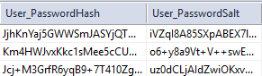

3.4 Email Notification
Purpose:
This feature is to notify the administrator when an event occurs such as login.

How it works:
- When an administrator account is logged in, an email notification is sent to their email.
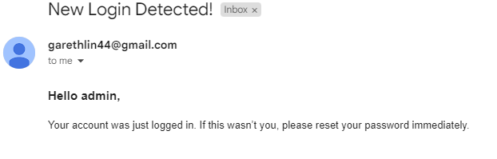

3.5 TOTP Verification

Purpose:
TOTP (Time-Based-One-Time Password) verification is used to enhance security by adding an extra layer of authentication and is also used for forgot password feature.

How it works:
- In ‘Settings’ page, administrator can choose to enable TOTP by clicking in TOTP button.
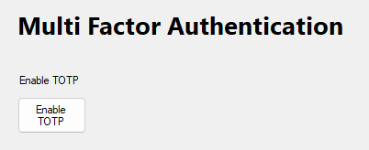
- When administrator clicks on the button, a TOTP Secret code is generated and stored in the database and a QR code appears on the screen that allows administrator to scan using apps such as google authenticator app.

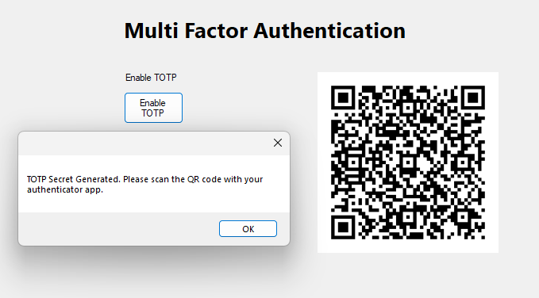
- After enabling TOTP verification, whenever the account is used to login, a TOTP verification will be prompted before login is successful. The administrator has to key in the code from their app.
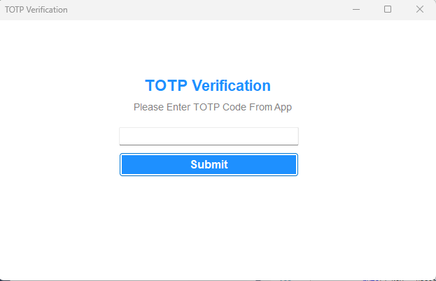
- If code is invalid, there will be an error message.
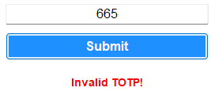

3.6 Session Management
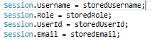
Purpose:
This feature is used to maintain user login state across different pages of the dashboard.

How it works:
- When user logs in successfully, the user ID and details will be stored in the session.

3.7 Admin Dashboard Layout
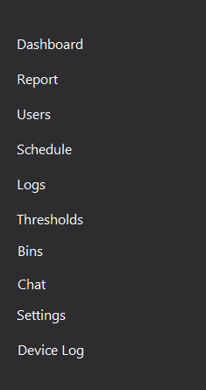
Purpose:
To create a consistent, structured, user-friendly and efficient interface that allows administrators to quickly access features.
How it works:
- Layout consists of a top navbar that has a title, a welcome text with session’s username, live clock and log out button.
- Layout also consists of side navbar that allows access to different pages of the system.

3.8 Account Management (CRUD)
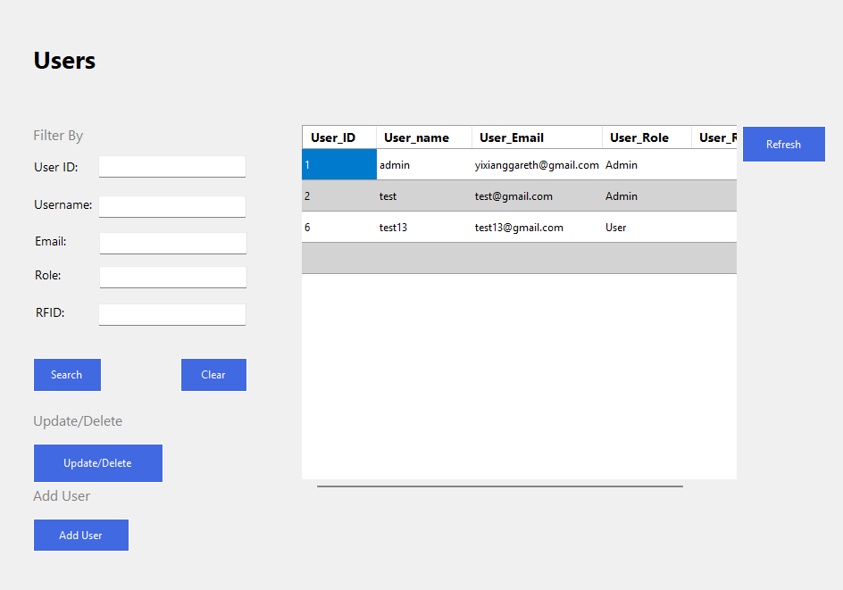
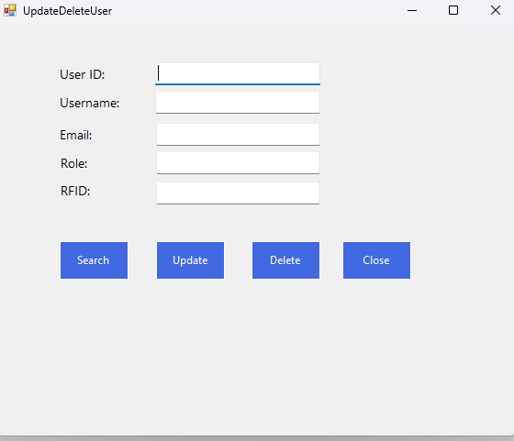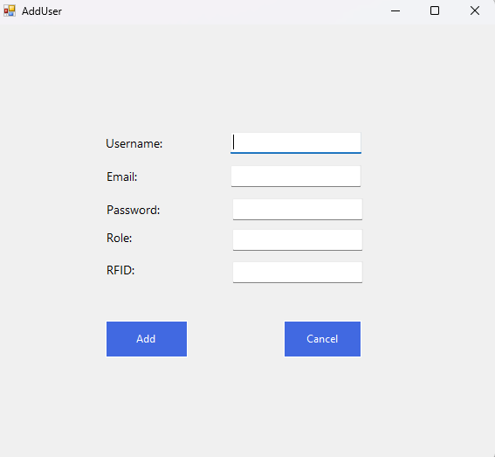
Purpose:
To allow administrators to efficiently manage user accounts, this includes creating, reading, updating deleting user accounts
How it works:
- Contains a grid view that displays user accounts data from database
- A search filter to search by different criteria
- An update/delete function where administrator has to key in the user id of who he wants to update/delete. After searching, administrator can decide whether to update or delete.
- An add user function where administrator can decide whether to add an ‘Admin’ or ‘User’. Username and Email cannot be reused.

3.9 Bin Management (CRUD)
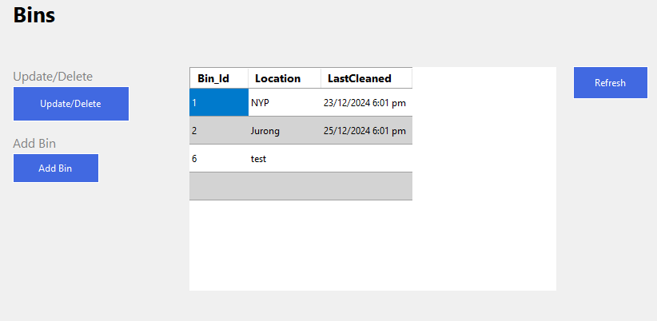
Purpose:
To allow administrators to efficiently manage bins, this includes creating, reading, updating deleting bins.
How it works:
- Contains a grid view that displays bin information from database.
- An update/delete function where administrator has to key in the bin id of which bin to update/delete. After searching, administrator can decide whether to update or delete.
- An add bin function where administrator can add a bin.

3.10 Dynamic Live Charts
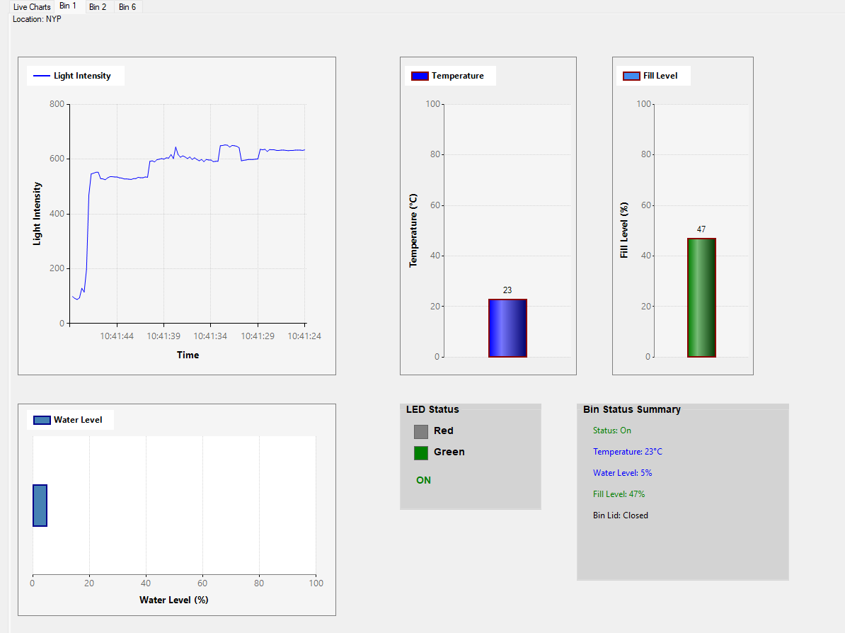
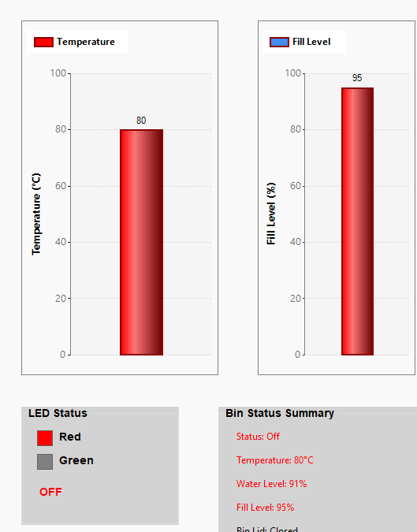
Purpose:
This feature provides real-time data visualization of hardware of bins.
How it works:
- The dynamic live charts are generated from back-end code and is displayed in tabs using data from the hardware table in database.
- By using tabs, administrator can swap views of different bins conveniently.
- It is automatically refreshed in set intervals using a timer.
- Whenever a hardware exceeds a threshold, the colour of temperature or fill level chart turns red and the LED status turns red.

3.11 Bin Status Summary
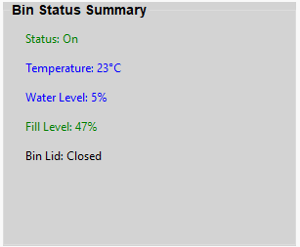
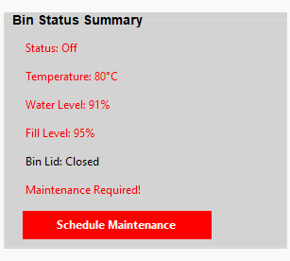
Purpose:
This feature provides a quick summary of the bin status, an alert and schedule button
How it works:
- This summary shows the status of bin whether is on or off, and the different conditions of the bin.
- Whenever a threshold exceeds, the ‘Maintenance Required’ message will appear and the ‘Schedule Maintenance’ button appears to allow convenient maintenance scheduling.

3.12 Logging
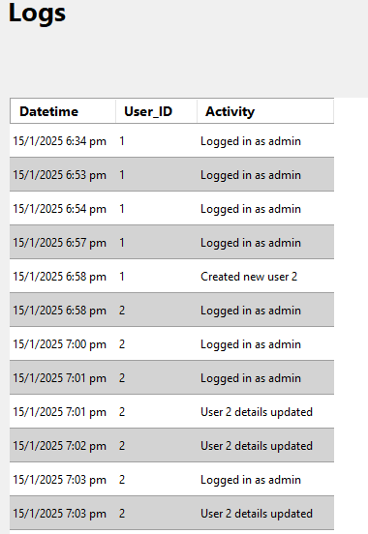
Purpose:
This feature provides accountability by tracking system activities and user actions.
How it works:
- Whenever an administrator logs in or creates or updates or deletes an user/bin, it will be logged and stored in the database.
- In the ‘Logs’ page, a grid view is used to display all the logs information from the database.

3.13 Hardware Data Sanitization

Purpose:
This feature is to process and validate hardware sensor data received by the admin WinForms.
How it works:
- Whenever admin WinForms receive data from hardware datacomms, it will undergo data sanitization before being stored in the database.

3.14 Light Sensor Insights Analytical Chart
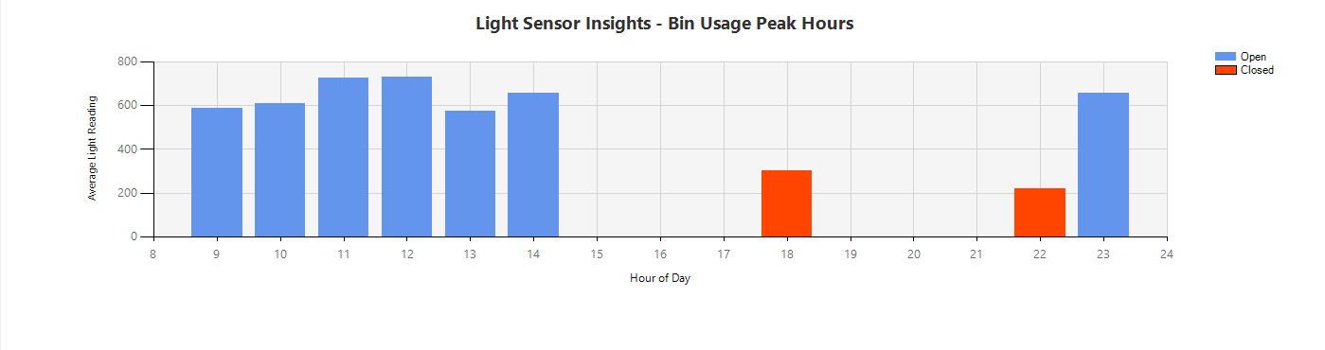
Purpose:
This feature is to visualize patterns and understand trends to allow administrator when to assign schedule for maintenance.
How it works:
- The chart displays the average light reading from different hours of the day from the database.
- When it is above the threshold, it will be considered open which means most of the time bin is being used and when below the threshold, it will be considered most of the time closed which means less/nobody is using.

3.15 Schedule Button

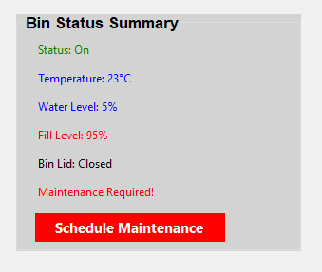

Purpose:
Clicking it allows admin to assign a user for maintenance.
How it works:
- Admin clicks on the button

3.16 Report

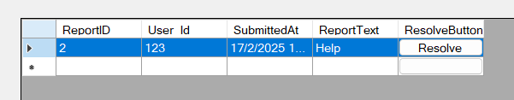

Purpose:
Allows Admin to view reports by other users, The resolve button allows us to hide the report, allowing admin to focus on the active reports. Hovering on it allows us to view any images the user has submitted with the report
How it works:
- User side adds a report, it can be viewed here.

3.17 Schedule

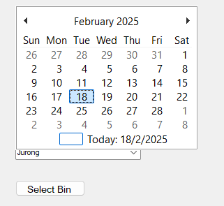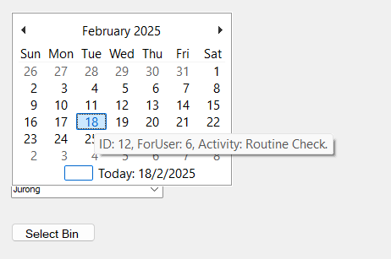
Purpose: View and add schedule events for users. Image shows admin adding a event for 18th Feb

How it works: Sql randomly selects a user, adds an event for the date selected. The page is constantly updating to ensure that the user is not added due to visual glitches.

3.18 Threshold
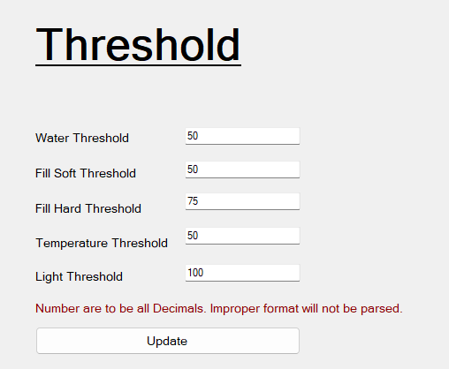
Purpose: To account for the environmental conditions of the bin, the admin can manually adjust the thresholds to reduce the false positive rates of the bin’s notification for need of maintenance.

How it works: Admin can input the threshold, this will be directly applied to the database, which is then updated to the dashboard.
3.7 Chat Messaging

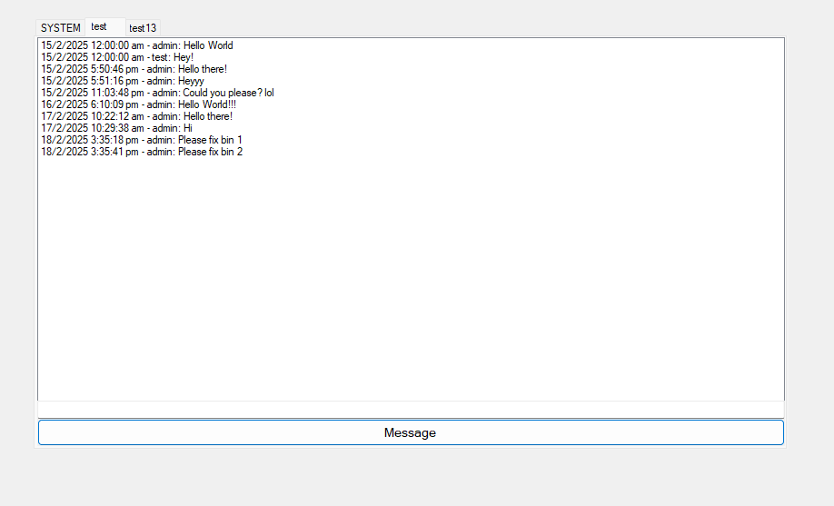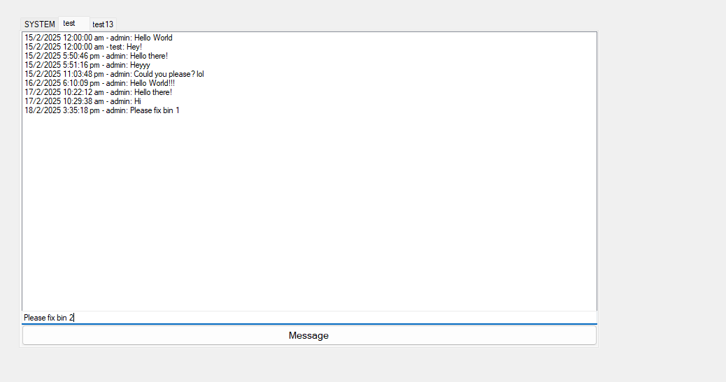
Purpose : For admin and user to be able to chat in one app, admin can add on specifications to the instructions for the user when they are performing their job. Users can also reply and ask for clarifications. The image above shows

3.19 Device Log

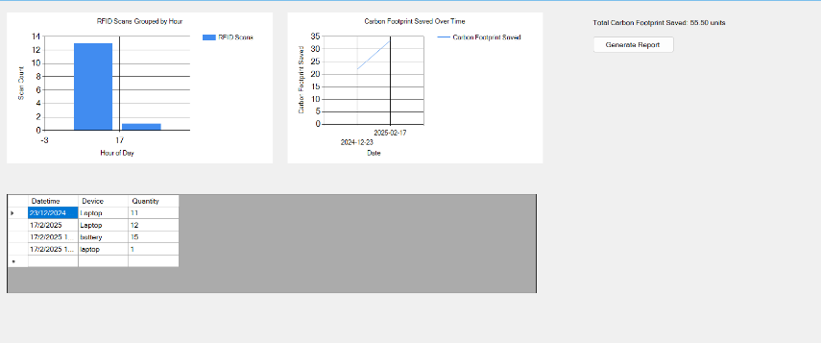
Purpose: The dashboard serves to track, analyze, and report e-waste collection activities while monitoring the environmental impact, specifically carbon footprint savings. It helps administrators and staff make informed decisions regarding e-waste management, ensuring efficient and eco-friendly disposal practices.
How it work :

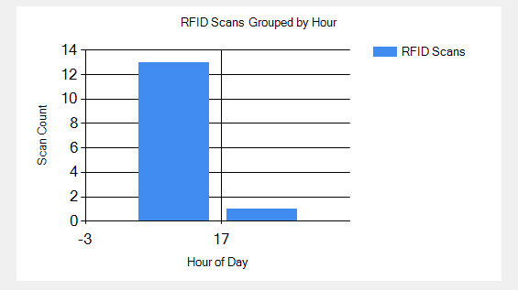
To monitor RFID scanning activity, helping administrators track collection patterns and identify peak operational hours.
- Shift Optimization: If collection consistently peaks at 21:00, administrators might consider optimizing staff scheduling for better efficiency.
- Evening Dependency: The heavy reliance on evening hours could indicate either operational constraints or strategic planning.
- Potential for Midday Collections: Introducing midday scanning sessions might balance the workload and improve efficiency.
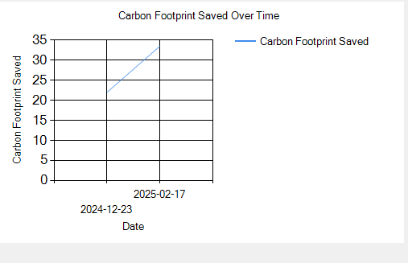
To track the cumulative carbon footprint savings from e-waste collection and recycling efforts over a given time period.
- Steady Progress: The consistent increase demonstrates the effectiveness of the recycling program.
- Potential Growth: If this trend continues, the organization could project future savings to set sustainability goals.
- Engagement Opportunities: Sharing this progress can boost stakeholder engagement by highlighting environmental benefits.
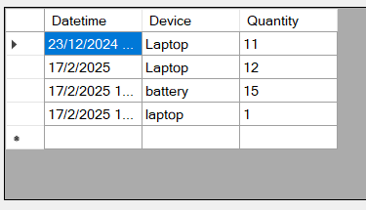
The table presents device collection data with corresponding dates and quantities.
- Data Consistency: Enforce uniform device naming (e.g., Laptop).
- Trend Analysis: Track quantities over time to identify collection patterns.
- Future Actions: Investigate if the battery spike reflects a one-time event or an emerging trend.

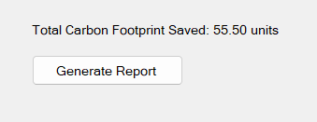
Shows total amount of carbon footprint saved. The generate report button creates a excel file, inputs the relevant data and opens the file. This is useful for further data analysis and pushing the environmental narrative.
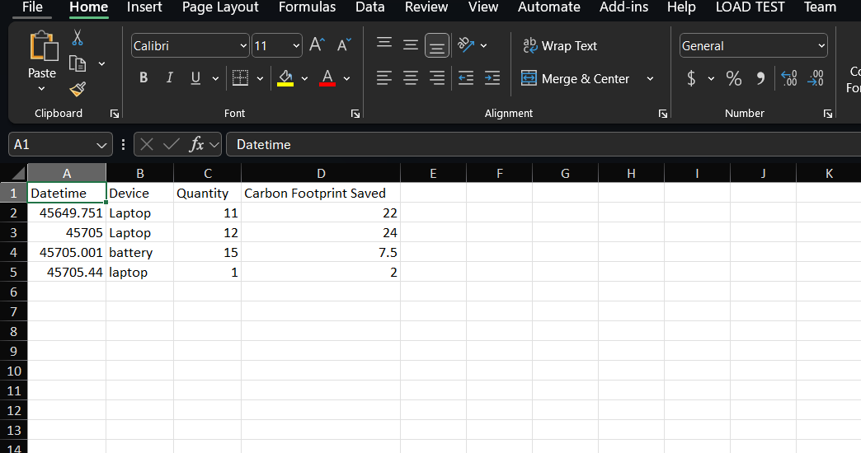

E waste Bin System Application | User

User Login page
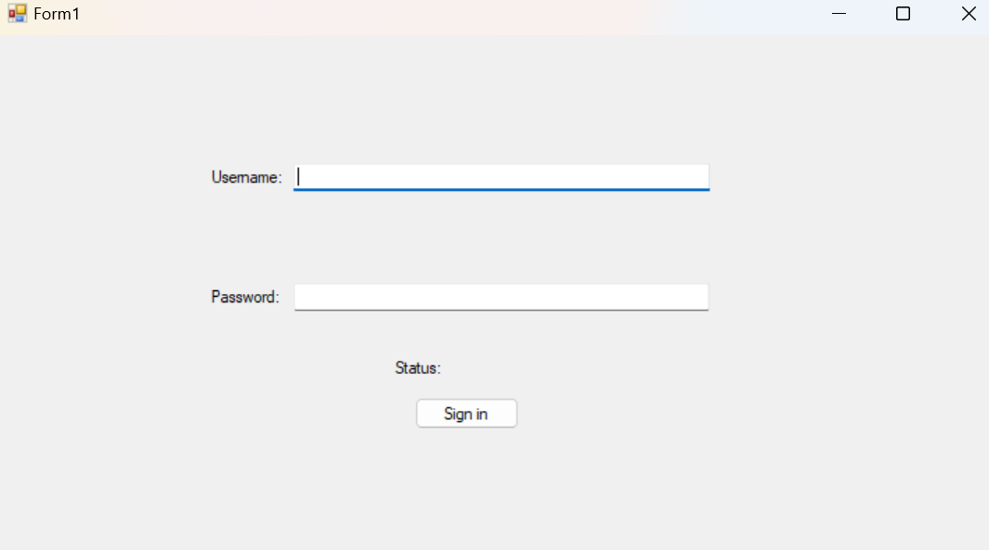
Purpose:
Login page that will Navigate to Landing page

How it works:
- User logs in with the correct credentials.
  - Username: admin
  - Password: admin123
- Any failed login will result in the status changing and an alert popping up
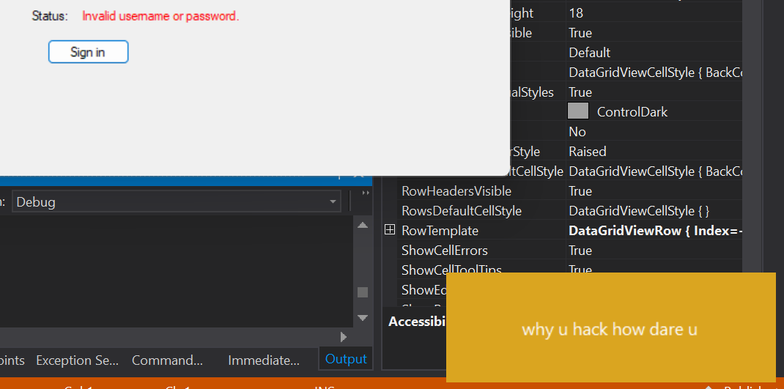

4.2 User Home Page
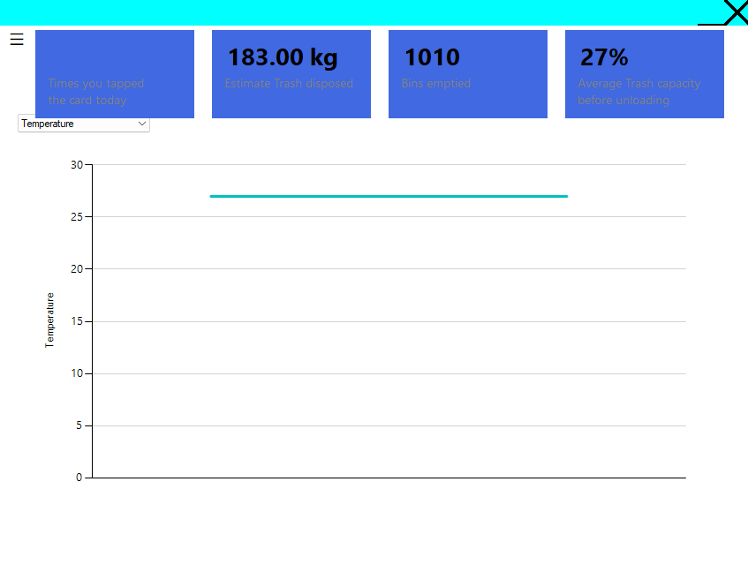

Purpose:
Landing page for the user, pulls the latest data from the database and updates the dashboard. The 4 Top stat cards pull different data from the database, from left to right: RFID status (Int), water level (Int), Light level (Int) and temperature (Int). There are 4 statuses for the stat cards: Grey if the data failed to update on the initial load, Red if the data is N/A, Green if the data has been updated once at least in 3 iterations, and Blue if the data has not been updated once in at least 3 iterations. The graph allows the user to choose which statistic of the bin they would like to view.

How it works:
- Data is consistently being pulled from the database, always taking the top entry.
- Graph is always updated over time, and is interactable to change which data they would like to know.
- System doesn’t check which entry is being taken, just taking the latest entry and plotting it over time.
- Simplified UI, only displaying necessary data for a custodian to complete their job.

4.3 Daily Statistics Page
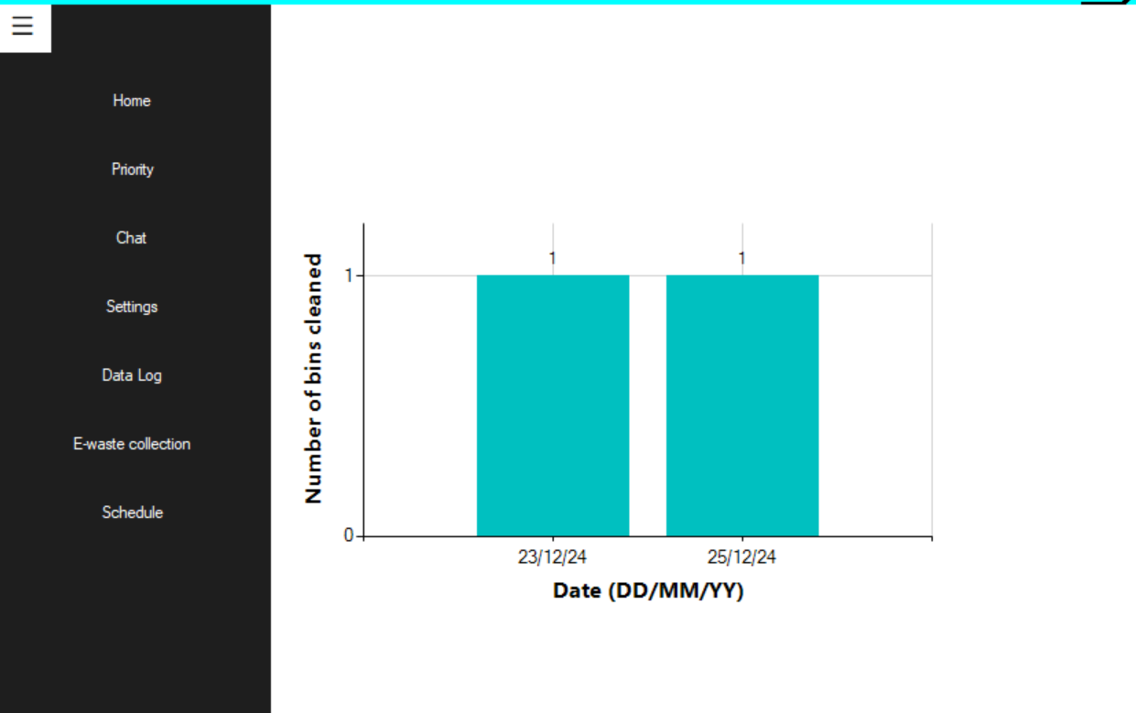

Purpose:
Allows the user to view the number of bins cleaned on which day.

How it works:
- Shows the number of bins on the top of each graph
- Graph is dynamic and taken from the database
- The date shows in DD/MM/YY format so that the user knows exactly the date that it is referring to

4.4 Priority Page

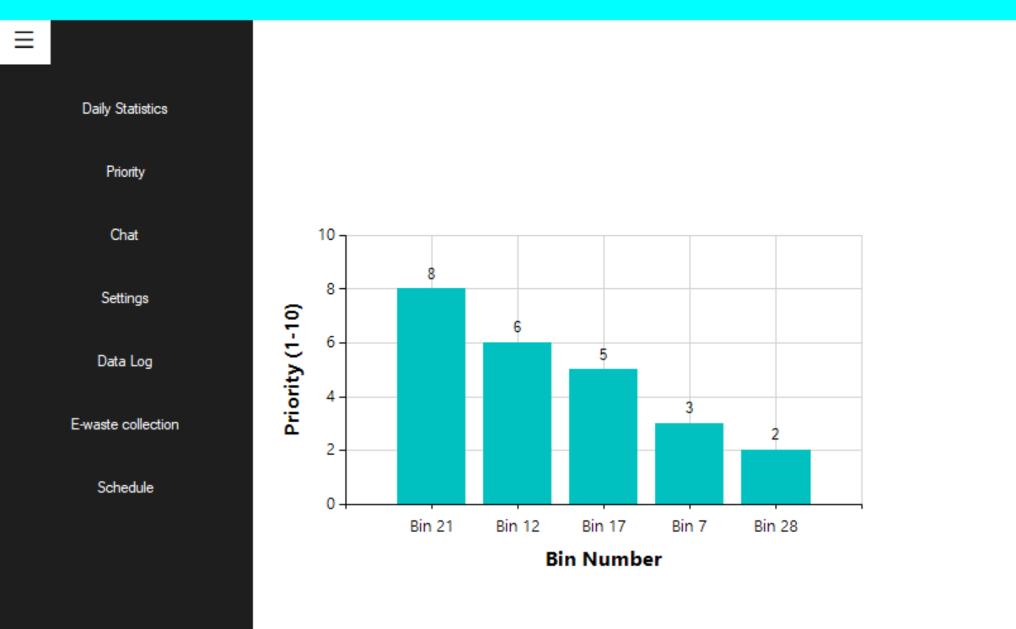
Purpose:
Able to see which bin has the highest priority that the user will need to focus on

How it works:
- Shows the Bin Number and the Priority from 1-10, 1 being the lowest
- The graph is arranged so that the bin with the highest priority is on the leftmost

4.5 Chat/Messaging Function
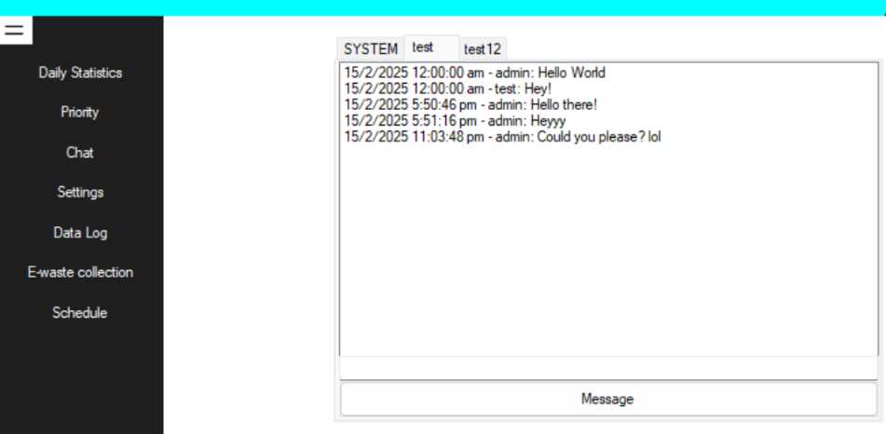
Purpose:
Able to chat with the admin side

How it works:
- The chat is stored in the database, where the messages typed by the admin will be stored and shown
- The same is done in the user side

4.6 Settings Page
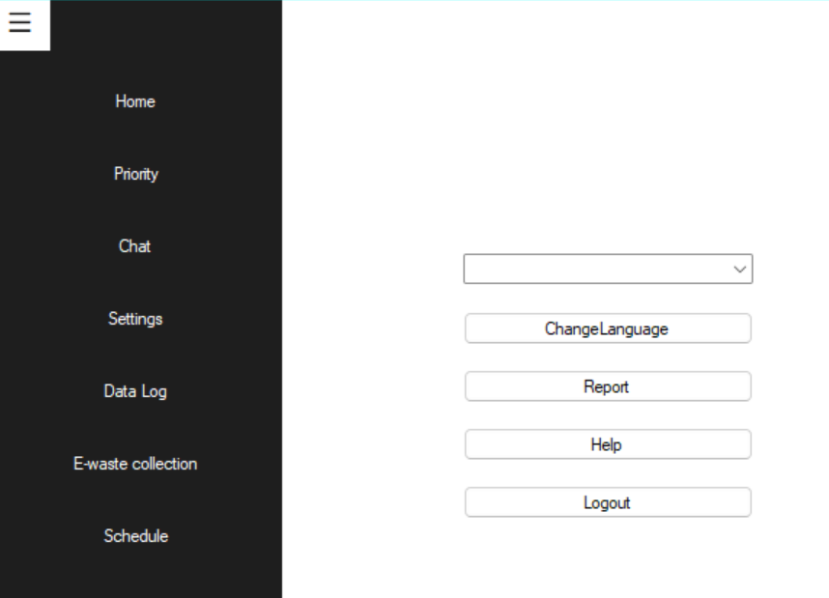
Purpose:
Able change the language, submit a report on faulty bins, check the help guide and logout.

How it works:
- The change language button will allow the user to change the language into 4 different languages (English, Chinese, Malay, Tamil)
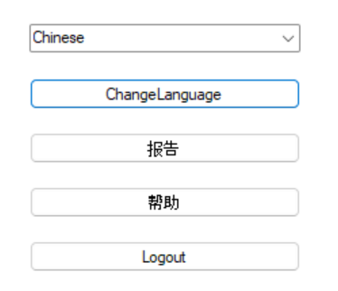
- The report will allow the user to report any faulty to admin, the username and the id is auto filled to prevent any human errors.
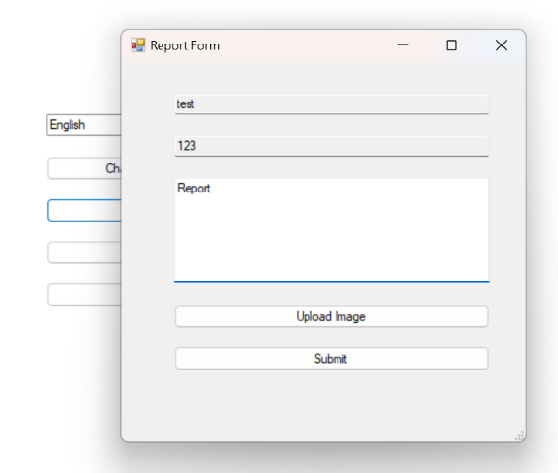
- The help button will go to a guide pdf
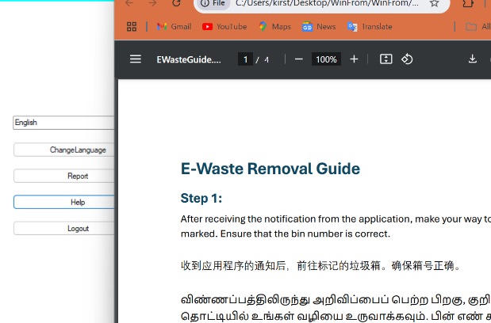
- Log out will bring the user back to the login page
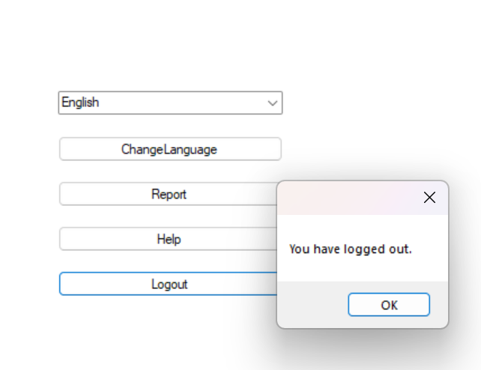

4.7 E-waste Collection Form
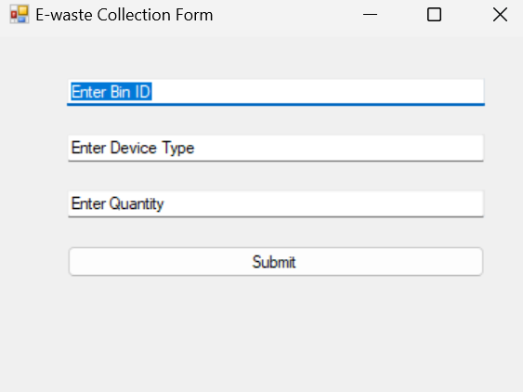

Purpose:
Allows the user to enter the device that they collect from the bins so that it can be used for future data analytics

How it works:
- The user enters the:
  - Bin ID
  - Device Type
  - Quantity
- The information will be stored in the database where it can be viewed in the admin side

4.8 Schedule
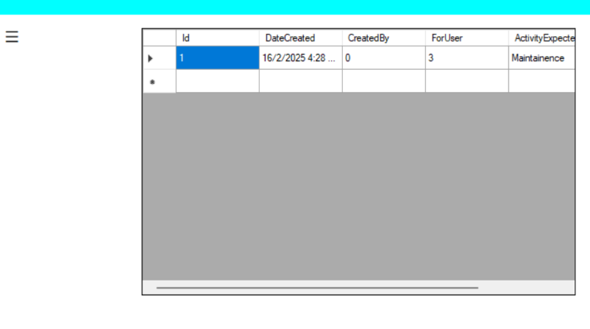
Purpose:
Allows the user to view the schedule that the admin has set up for them

How it works:
- The grid view allows the user to view the ID, date of the schedule created, who it is created by (0 = admin), who it was created for and what activity is needed to be done

4.9 Log
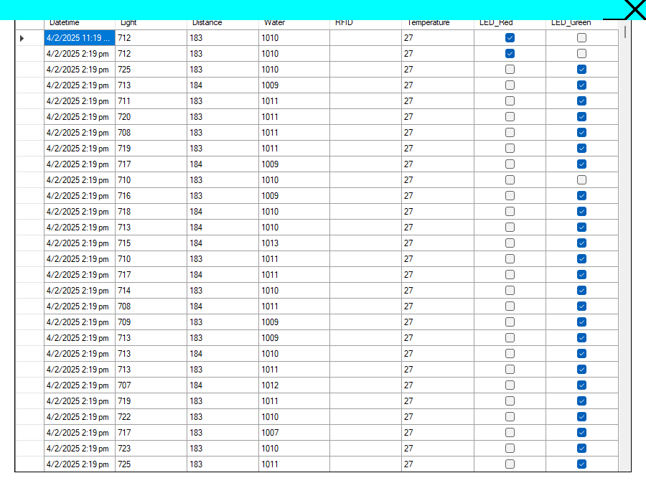
Purpose:
Allows the user to check the previous data entries to ensure that there is nothing wrong with the data, or analyse any operational errors.

How it works:
- Pulls all previous entries from the database for the bins table. Displays them in an organized fashion for the user’s perusal.

